Jules Horowitz Reactor (JHR) project : a future Material Test Reactor in support to nuclear industry, regulators and R&D institutes :status as of mid-2023 following major reassessment of the project and setting-up of « pre-JHR » phase before start-up of the reactor.
Dr G. Bignan, F. Carle, Dr JP Chauvin, M. Libessart
French Atomic and Alternatives Energies commission (CEA)
Cadarache Research Center
JHR project /reactor studies department
Contact : gilles.bignan@cea.fr

Introduction & Context within French Strategy
The Jules Horowitz Reactor (JHR) is a new Material Testing Reactor (MTR) currently under construction at CEA Cadarache research center in the south of France. It will represent a major research infrastructure for scientific studies dealing with material and fuel behavior under irradiation (and is consequently identified for this purpose within various European roadmaps and forums; ESFRI, SNETP…). The reactor will also contribute to medical Isotope production.
The reactor will perform R&D programs for the optimization of the present generation of Nuclear Power Plants (NPPs), support the development of the next generation of NPPs (mainly LWRs) and also offer irradiation capabilities for future reactor materials and fuels.
JHR is fully optimized for testing material and fuel under irradiation, in normal and non-normal conditions:
- with modern irradiation loops producing the operational condition of the different power reactor technologies,
- with major innovative embarked in-pile instrumentation and out-pile analysis to perform high-quality R&D experiments,
- with high thermal and fast flux capacity to address existing and future NPP needs.
JHR is designed, built and will be operated as an international user-facility open to international collaboration. This results in several aspects:
- a partnership with the funding organizations gathered within an international consortium,
- setting-up of an international scientific community around JHR through seminars, working groups to optimize the experimental capacity versus future R&D needs.
- preparation of the first JHR International Program potentially open to non-members of the JHR consortium.
It will answer needs expressed by the scientific community (R&D institutes, TSO…) and the industrial companies (utilities, fuel vendors…).
Consequently, the JHR facility will become a major scientific hub for cutting edge research and material investigations (multilateral support to complete cost effective studies avoiding fragmentation of scientific effort, access to developing countries to such state of the art research reactor facilities, supra national approach….).

European Material Testing Reactors (MTR) have provided an essential support for nuclear power programs over the last 50 years within the European Union.

However, the large majority of these Material Test Reactors (MTRs) will be more than 50-60 years old this decade, leading to the increasing probability of some shutdowns for various reasons (life-limiting factors, heavy maintenance constraints, possible new regulatory requirements…). Such a situation cannot be sustained in the long term.
On the other hand, associated with hot laboratories for the post irradiation examinations, MTRs remain key structuring research facilities for the European Research Area in the field of nuclear fission energy.
MTRs address the development and the qualification of materials and fuels under irradiation with sizes and environment conditions relevant for nuclear power plants in order to optimize and demonstrate safe operations of existing power reactors as well as to support future reactor design:
- Nuclear plants will follow a long-term trend driven by the plant life extension and management, reinforcement of the safety, waste and resource management, flexibility and economic improvement.
- In parallel to extending performance and safety for existing and power plants to come, R&D programs are taking place in order to assess and develop new reactor concepts (Generation IV reactors) that meet sustainability purposes.
- In addition, for most European countries, keeping competences alive is a strategic cross-cutting issue; developing and operating a new and up-to-date research reactor appears to be an effective way to train a new generation of scientists and engineers.

Focus on French Strategy

Following the multi-annual energy plan (MEP/PPE) performed in the previous year’s affirming that nuclear energy is a long-term option in the frame of a more balanced electricity mix, the key action was the announcement on 10th February 2022 by the French president on the decision to launch new NPPs (EPR type) to progressively replaces some of the operating NPPs. President Macron expressed his wish on November 2021 and February 2022 that, in addition to pursuing the massive development of renewable energy sources, a new nuclear reactor construction program of 6 new EPR2-type reactors be undertaken to guarantee France's energy independence and achieve carbon neutrality by 2050, and that studies be started for 8 more.
In the same time, a major investment plan for the future, "France 2030", was launched. One objective of this plan is to promote the emergence in France of small and other innovative nuclear reactors. The French Nuward small modular reactor (SMR) project should thus benefit from a substantial portion of the allocated support (approximately €500 million) to accelerate its development, with the goal of starting construction of a first unit by 2030. The other part of the France 2030 budget (approximately €500 million) will be allocated to innovative reactor projects, based on a call for projects (CFP) that was published in March 2022.
Following this announcement, a project of law on “acceleration for building new nuclear facilities” has been submitted by the French Government end of 2022 and after several debates, this law has been endorsed by the senate and the parliament in May 2023.

This strategy leads to the fact that JHR will be -once in operation- a paramount research reactor in support for the present French fleet of NPPs but also on the coming one.

Moreover, one should quote the key-role of the JHR for a sustainable supply within the European Union of radioisotopes for medical application considering the ageing fleet of MTRs in operation today.

1] Highlights of the JHR project

JHR will offer modern irradiation experimental capabilities to study material & fuel behavior under irradiation. JHR will be a flexible experimental infrastructure to meet industrial and public needs within the European Union related to present and future Nuclear Power Reactors.
JHR is designed to provide high neutron flux (notably twice as large as the maximum that were available in the past French MTR OSIRIS and at the best standards worldwide) in order to:
- run highly instrumented experiments,
- support advanced modelling giving prediction beyond experimental points,
- operate experimental devices giving environment conditions (pressure, temperature, flux, coolant chemistry, …) relevant for water power reactors (PWRs, BWRs, VVERs), but also in support of non-water reactors R&D (Sodium cooled fast reactors…).
These objectives require representative tests of structural materials and fuel components as well as in-depth investigations with “separate effects” experiments coupled with advanced modelling.
For example, the JHR design accommodates improved on-line monitoring capabilities such as a fission product laboratory directly coupled to the experimental fuel sample under irradiation.
As a modern research infrastructure, JHR will contribute to the development of expertise, and to the training of the next generation of scientists and operators with a positive impact on nuclear safety, competitiveness and social acceptance. The JHR is designed mainly to meet these technical objectives.
As an associated objective, the JHR will also contribute to secure the production of radioisotopes for medical applications.

JHR, as a future international User Facility, is funded and steered by an international consortium gathering industry (Utilities, fuel vendors…) and public bodies (R&D centers, TSO, Regulator…). The generic model of JHR consortium is the following:
- CEA is the owner and the nuclear operator of the nuclear facility with all liabilities,
- JHR Consortium Members own Guaranteed Access Rights to the experimental capacities in proportion to their financial commitment to the initial cost of construction and with a proportional voting right in the Consortium Governing Board,
- A Member can use totally or partly his access rights for implementing proprietary programs with full property of results and/or for participating to the Joint International Programs open to non-members
- JHR consortium membership is open to new members.
CEA is encouraged by the consortium to enlarge JHR membership and, as of mid-2023, the members list of JHR consortium is the following:
CEA (France), EDF (France), FRAMATOME (France), TECHNICATOME (France), AREVA-SA (France), European Commission-JRC, SCK CEN (Belgium), CVR/UJV (Czech Republic), VTT(Finland), CIEMAT(Spain), STUDSVIK (Sweden), DAE(India), IAEC (Israel), NNL (UK), CGN (China).
A more extensive and in-depth JHR facility description including development of the first experimental capacity can be found in the proceedings and presentations of recent RRFM and IGORR conferences (see also this conference).

2] JHR general description

As a short description, the JHR layout is as follows:

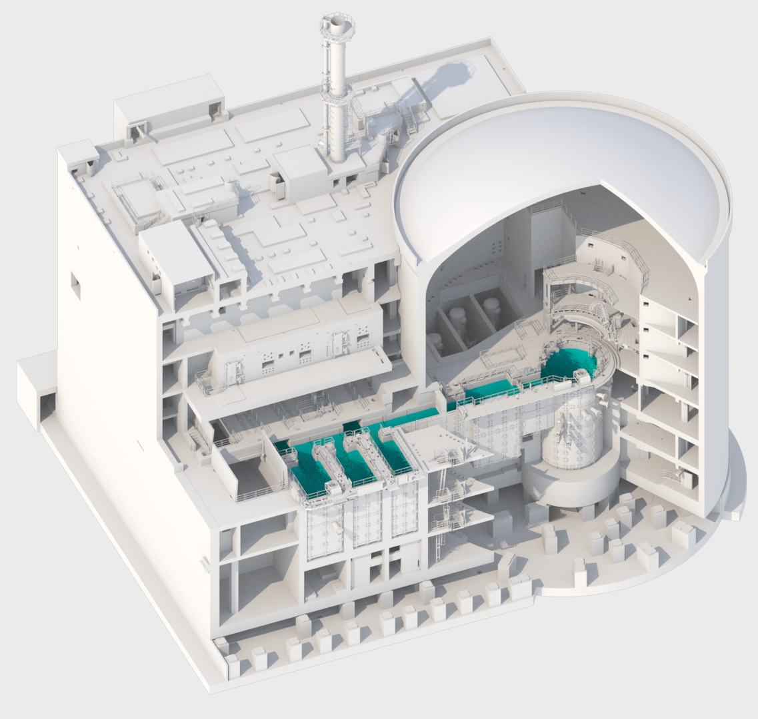

The nuclear unit of JHR consists in a reactor building and a nuclear auxiliary building.
The reactor building consists in pre-stressed concrete with a diameter of 37 m. The nuclear auxiliary building consists in 3 storage pools for spent fuels, irradiated experimental devices and in 7 hot cells for preparation, conditioning of experiments and non-destructive examinations on irradiated samples. An underwater channel between the reactor building and the nuclear auxiliary building allows the transfer of spent fuels and experimental devices between the two buildings.
In support to the nuclear island, one can quote the following:
- 1 support building for cooling
- 2 emergency diesel generators buildings
- 1 building for assembly and test of experimental devices before entering the nuclear island (“cold workshop”)

3] Developing a modern experimental capacity

JHR is designed as a High Performance MTR (thermal power up to 100 MW) with the capacity to perform up to 20 experiments at the same time. Characteristics (at full 100 MW capacity) are as follows:
- thermal neutrons flux in reflector: up to 5.10¹⁴ n/cm².s
- fast neutron flux in the core: up to 5.10¹⁴ n/cm².s for E > 1 MeV and/or up to
10¹⁵ n/cm².s for E> 0.1 MeV
- material ageing: up to 13 dpa/y
- 4 displacement systems to adjust fissile power and perform power transients
- power transients for fuel limit to clad failure studies: up to 600 W/cm.
At nominal operation JHR is to operate with in average 6 cycles a year.
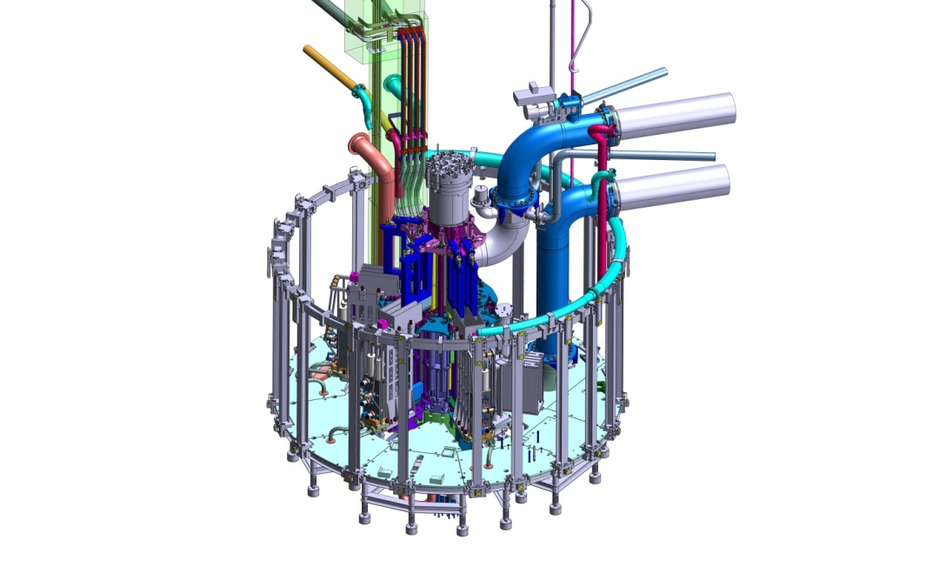
schematic view of JHR core and reflector where will be located experimental loops
Compared to the existing experimental capacities worldwide, a great effort is ongoing to improve the performance of such loops and to develop new devices with innovative concepts by:
- better monitoring and follow-up of the irradiation conditions,
- having a lot of on-line instrumentation to address key parameters (fast and thermal neutron fluxes, gamma heating, temperature, fission gas release for fuel investigation, material elongation…),
- having up-to-date post-irradiation exams either directly within JHR nuclear building (for non-destructive tests) or in Cadarache Hot Laboratory (for NDT and destructive tests) or in Consortium Members Hot Laboratory.

Several publications have been done to present in detail the JHR experimental capacity under development (see Gonnier et Al [IGORR 2019] or Kinnunen et Al [FISA 2022].

4] JHR as an International User-Facility through International Joint Programs and /or Academic Support

Parallel to the construction of the reactor, the preparation of an international community around JHR is continuing. This is an important topic because, as already indicated, building and gathering a strong international community in support to MTR experiments is a key-issue for the R&D in nuclear energy field.
According to the consortium agreement, JHR is aimed to become a user reactor at international level (cf achievements of the OECD/Halden Reactor Project) with multinational project and proprietary experiments. As anticipated preparatory actions, the JHR consortium has set-up a yearly scientific seminar and three working groups (Fuel, Material and Technology) to identify R&D topics of common interests and to prepare the first international joint programs addressing fuel and material issues that are key for operating plants and future NPP (mainly focused on LWR).

This yearly seminar (the 12^{h} seminar will be held early June 2023)-gathering about 80 participants- is a unique opportunity for the future end-users to share and discuss progress on the latest developments on JHR experimental capacities. The main outputs of such seminars allows to identify scientific needs leading to proposal of future R&D programs with precise requirements regarding the management of irradiation conditions and the performances associated to the instrumentation of the experimental devices.
The priorities given by the participants for future programs (Fuel behavior investigation under normal, incidental and accidental conditions –Material behavior such as Reactor Pressure Vessel, Internals studies under irradiation) give confidence on the well-designed future JHR experimental capacity.

5] New organization as of March 2020-Main outcomes

A new organisation has been set-up in March 2020 to secure the completion of the project. The implementation of the Recovery Action Plan decided in 2019 let to a major reassessment of the project through a new organisation focused on delivery with alignment of the main subcontractors in order to finalize the detailed design and the layout (3D model) of the reactor (Integrated plateau gathering CEA,FRAMATOME, TECHNICATOME and the main subcontractors of the supply chain).
The main topics addressed during this 2020-2023 roadmap are the following :
1st phase: 2021-2023
- Completion of detailed design and finalization of layout (3D model)
- Closure of remaining technical open points
- Manufacturing and qualification of critical equipment
- Installation in limited areas in order to get feedback
This phase led to the completion of detailed design by the main contractors (finalization of the 3d model, integration of last modifications for the erection phase, confirmation of bills of quantities…)
In November 2022, a detailed maturity review took place in order to assess the readiness for the full speed installation phase later on.
The objectives of this maturity review were the following:
- validation of a frozen, consistent and acceptable technical perimeter
- provide inputs to reassess a reliable overall schedule (design/installation/commissioning),
- provide inputs for estimating the cost at completion and the update of contracts.
This maturity review concluded that the project was now stabilised and ready to go further and proceed until completion.
CEA submitted the revised JHR project roadmap to the French Government in January 2023 and expects a greenlight to enter the next phase by mid-2023.
2nd phase: after 2023
Once the feedback from the French Government has been obtained, the activities at site will accelerate in order to reach installation at full speed up to commissioning tests and start-up (criticality).
This reassessment of the project lead to the fact that the start-up of the reactor is foreseen in the course of the next decade. Consequently, the international JHR consortium has decided to launch a « pre-JHR » phase by performing R&D programs on fuel & material in today’s operating MTRs (BR2, HFR, LVR15, ATR…) in order to optimize the future experiments in the JHR.

Conclusion
Due to the ageing fleet of the Material Test Reactors in operation today, JHR as being the only one under construction in support to LWR NPPs (water-cooled research reactor) will become –once in operation- a major international research infrastructure for fuel and material qualification under neutron irradiation but also for radioisotopes for medical applications.
The new organisation of the project set-up in March 2020 and its associated roadmap has greatly help to give confidence to the French Government and CEA’s industrial partners for the completion of the project.

